EXERCISE 10 - JEAN RAVEN MAGALING

- Display the sum of ages of employees working at Bignet.
SELECT SUM(age) AS total_age_of_employees
FROM employee_data;
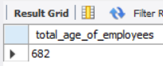
- How would you calculate the total years of service the employees of Bignet have in the company?
SELECT SUM(yos) AS total_years_of_service
FROM employee_data;
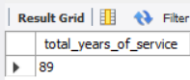
- Calculate the sum of salaries and the average age of employees who hold “Programmer” title.
SELECT
SUM(salary) AS total_programmer_salary,
AVG(age) AS average_programmer_age
FROM employee_data
WHERE title = 'Programmer';
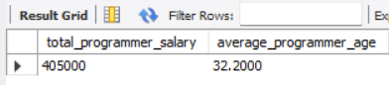
- What do you understand from the following statement?
SELECT (SUM(perks)/SUM(salary) * 100)
FROM employee_data;
This SQL statement calculates the percentage ratio of total perks compared to total salary. It tells you how much perks cost as a percentage of the total salary budget.

